**Activity 1**

**Resource utilization and school cleaning**

**1.Executive Summary or Abstract:**

In this activity, I, with the help of others, cleaned the Government Higher Primary School in Hosakote Taluk, Bangalore Rural District and also taught and created awareness about Female Sanitation, Menstruation and Hygiene. We conducted an activity and awareness program in the Khazimakan Hosakote Town from 9th January - 22nd January, 2023.

**2. Introduction:**

“When there is both inner and outer cleanliness, it approaches godliness”

-Mahatma Gandhi

Swachh Bharat Abhiyan, also known as the Clean India Mission, is a country-wide campaign initiated by the Government of India in 2014 to eliminate open defecation and improve solid waste management. The Swachh Bharat Abhiyan is the most significant cleanliness campaign by the Government of India, covering 4041 statutory towns to clean the country. The campaign has been successful in increasing rural household toilet coverage in India and reducing open defecation. Overall, Swachh Bharat Abhiyan is an important initiative that aims to create a clean and healthy India by promoting cleanliness, hygiene, and sanitation practices. Clean schools are essential for promoting a healthy and conducive learning environment in rural areas. Unclean schools can cause children to become sick more often and sap their morale, sending a message that the teachers and faculty members do not care enough about the students to keep the school clean. Hence, clean schools are essential for promoting good health, academic performance, and well-being among rural school children, and it is important to provide access to clean water, sanitation, and hygiene facilities. Spreading public awareness under rural outreach programs is a process that seeks to inform and educate people about a topic or issue with the intention of influencing their attitudes, behaviours, and beliefs towards the achievement of a defined purpose or goal. The objective of awareness-raising is to mobilize the power of public opinion in support of an issue and thereby create an enabling environment for accountability, promote participatory and inclusive processes for follow-up and review, and build ownership of the 2030 Agenda. Awareness-raising efforts may include issuing press releases, briefings, and commentaries; disseminating reports, studies, and publications; making written or oral submissions to parliamentary committees and inquiries; working with the media; holding public meetings, workshops, and seminars; and using social media platforms. Rural outreach programs have been shown to have a positive impact on medical students' future rural intentions and working locations. However, these programs require further refinement and the specific aspects of the programs that are contributing to rural practice need to be explored. Programs should incorporate pre and post surveys to assess the change in participants after the program intervention and to collect important participant characteristic information. In the context of natural disasters, awareness and preparedness are the most effective prevention and mitigation strategies. The local community coming together for rescue missions and volunteering in relief camps has an enormous impact on the return to normalcy. Public awareness strategies can be used to effectively conduct outreach and promote culturally-sensitive public awareness.

**3. Description of activity with photographs:**

As a part of social activity and also to achieve the activity points, me and my fellow students of JSSATE undertook an initiative to clean the premises of the Government Higher Primary School in Khazimakan Hosakote Town to help improve the condition and environment of the school, and make it a healthy and safe place to study. We have swept the floor and arranged the books in the classroom to improve the neatness of the classroom. And also have arranged new notebooks for the students in the school. After cleaning the classroom, it is handed over to the school committee. Next, we conducted an awareness and outreach program to spread awareness about Menstrual Hygiene and Female Sanitation. Upon surveying, we found that a lot of women in under-privileged families did not dispose of menstrual pads properly, and also did not get the budget-friendly pads available in the government clinics. We discussed this issue in local languages with the women and communicated the correct methods to them.

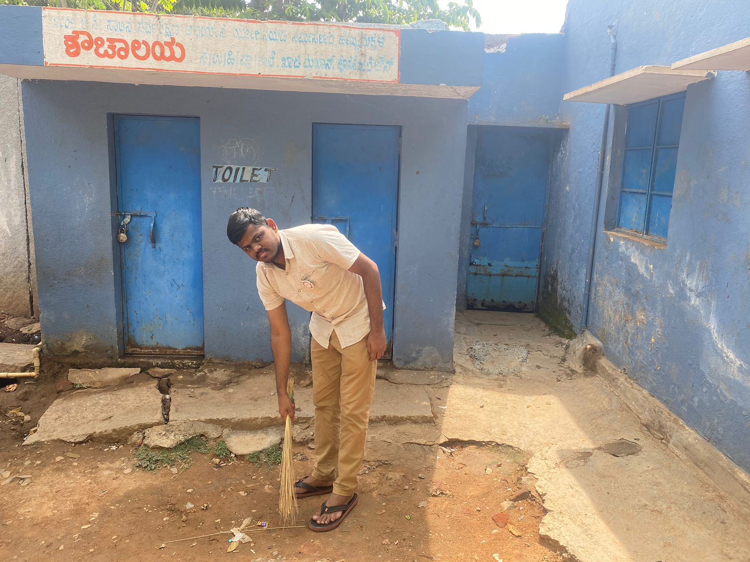

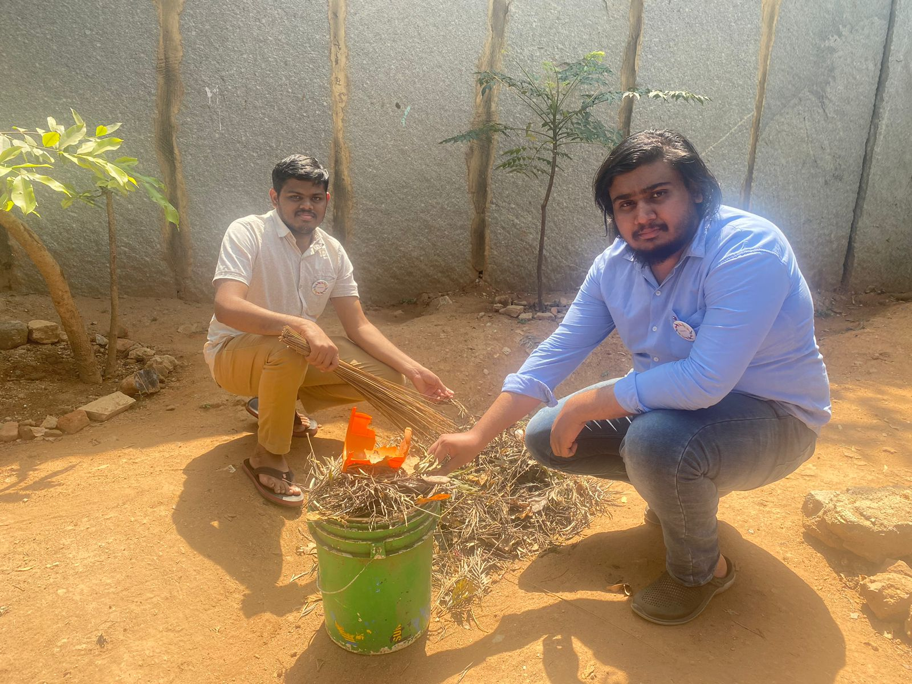

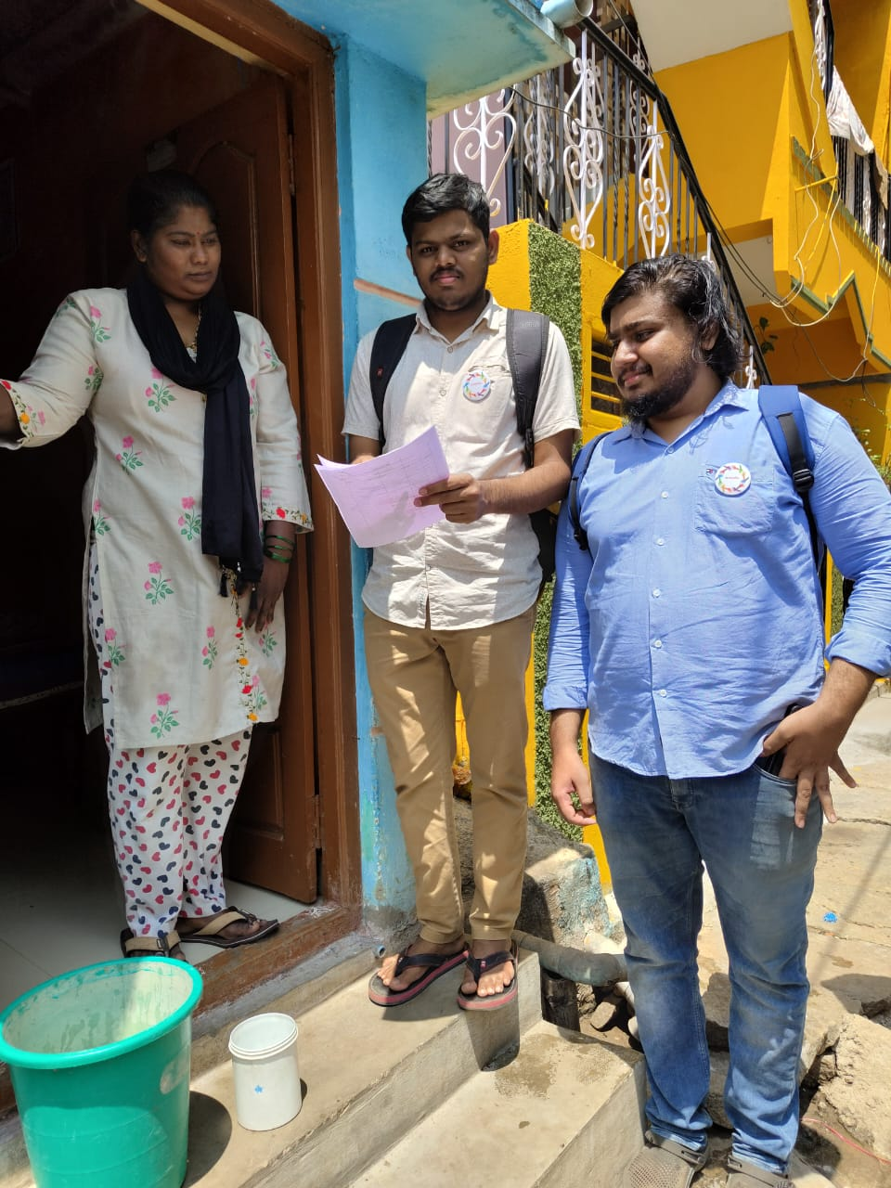

**4. Conclusion:**

We were able to successfully clean the Government Higher Primary School in Hosakote Taluk, Bangalore Rural District and also taught and created awareness about Female Sanitation, Menstruation and Hygiene dated 9th January - 22nd January, 2023.

**5. Outcome or Takeaways from the activity:**

From this activity, we learned that it is crucial for underprivileged students to have access to education and opportunities to study. Maintaining clean classrooms is crucial for promoting a healthy and conducive learning environment. A clean classroom minimizes the spread of germs, reduces illnesses, and promotes healthy habits among students. Educated individuals can communicate effectively and have better health outcomes. Offering underprivileged students more than just a merger "stay in school" is necessary to ensure that they have access to the same opportunities as their more affluent peers. Overall, education is a powerful tool for breaking the cycle of poverty and promoting social mobility, and it is essential to provide underprivileged students with the resources and support they need to succeed. We also understand that female sanitation and menstrual hygiene is crucial for the health and well being of poor women. Poor menstrual hygiene can lead to urinary or reproductive tract infections and affect the well-being of women. Lack of access to menstrual hygiene products and facilities can cause menstrual health needs to go unmet, leading to social and economic inequalities. Disposing of sanitary napkins, the right way is important to prevent the spread of infections and bacteria, as germs thrive on blood exposed for long duration. Burning plastic sanitary napkins causes harmful toxins to be released into the atmosphere, and it is not an environmental-friendly solution. Practicing safe disposal techniques is important for our health and hygiene as well as for the ecosystem, as most of these products are non-biodegradable and can cause environmental pollution. Improving menstrual hygiene and providing access to affordable menstrual materials can help improve women's access to education, job opportunities, and entrepreneurship, thus unleashing female contributions to the overall economy.

**Certificate:**

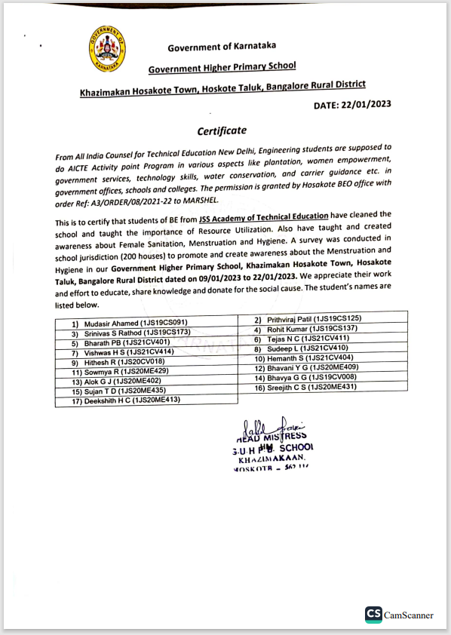

**ACTIVITY 2a**

**HAM radio communication and career guidance**

**1.Executive Summary or Abstract:**

ABOUT TECHNICAL EDUCATION

A career and technology-based education will help your child to be more than just an average student. Career and technology education can give your child what’s needed to succeed for life: technical skills, academic skills and employability skills.

**2. How does it work?**

Amateur radio operators - and they can be doctors, students, kids, politicians, truck drivers, movie stars, missionaries and what you - share a basic knowledge of radio technology and operating principles, and pass an examination for a license issued by the Federal Communications Commission (FCC). The license allows ham radio operators to operate on radio frequencies allocated by the FCC for use; these frequencies are also known as the “Amateur Bands.” Be it through Morse Code on an old brass telegraph key, voice communication on a hand-held radio or computerized messages transmitted via satellite, all hams use radio to reach out to the world. Hams can operate from just above the AM broadcast band to the microwave region, in the gigahertz range. Many ham bands are found in the frequency range that goes from above the AM radio band (1.6 MHz) to just above the citizens band (27 MHz). During daylight, 15 to 27 MHz is said to be a good band for long-distance communications. At night, the ideal band for is 1.6 to 15 MHz These bands are often referred to historically as short-wave bands (representing short-wave radio). Unlike frequencies used by FM radio stations and TV stations, which are line-of-sight and therefore limited to 40 or 50 miles, short-waves bounce off the ionosphere from the transmitter to the receiver’s antenna. The higher the frequency is, the shorter the wavelength. Some ham radio operators use the very dependable Morse code, while others rely on voice. Morse code signals (beeps) often get through when voice transmissions cannot.

**3. Description of activity with photographs:**

It was a great experience to share my knowledge about HAM Radio communication and create awareness on how they work. I taught government school students about the HAM Radio communication and technology and where it is used, how it is used and how it works and mainly it is used in military police departments.

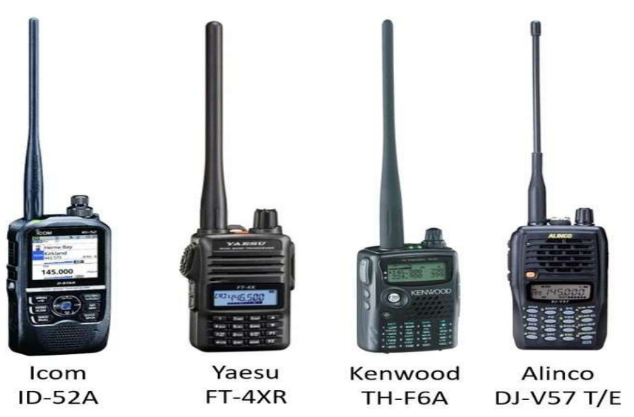

Fig: Different types of ham radios

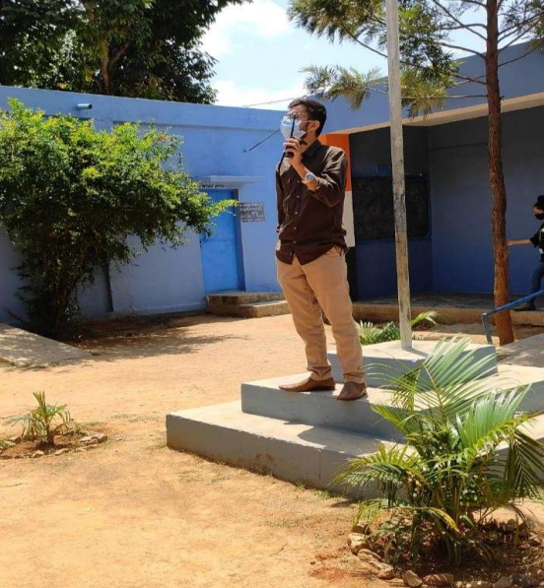

Fig: Ruman Sait U (President) explaining about HAM radio

**4. OUTCOME:**

Regardless of whether students are headed for college or the workforce, this type of education will help them prepare for the future. In fact, this type of technical seminar will help the under privileged to gain more knowledge about the ham radio communication system where it is used and how it works. The government school students were very enthusiastic and eager and were motivated to learn about the technology.

* A ham radio license allows you to communicate over long distances without the internet or cell towers.
* Cell phones and the internet rely on a massive network of cables and giant data centers.
* Can use your amateur radio license to volunteer and assist during an emergency.
* Software Infrastructure: communication can fail due to hacking, bugs, and other software failures.
* Learn a new skill to add to your resume.

**5. CONCLUSION OF THE ACTIVITY:**

This enables communication across a city, region, country, continent, the world, or even into space. In many countries, amateur radio operators may also send, receive, or relay radio communications between computers or transceivers connected to secure virtual private networks on the Internet.

**Activity 2b**

**ABOUT CAREER GUIDENCE AND IMPORTANCE OF EDUCATION**

**1.Executive of Summary or Abstract:**

Career guidance is a process that helps individuals identify and explore career options, make informed decisions about their future, and develop strategies to achieve their goals. It can be helpful at any stage of life, but it is especially beneficial for young people who are just starting out in their careers.

**2. Introduction:**

Career guidance is essential for underprivileged students as it can help them make informed decisions about their future and develop essential skills to earn a living. Effective career guidance encourages students to reflect on who they are, who they want to become, and to think critically about their career aspirations. Underprivileged children grow up in different environments and have different learning requirements, and education needs to be customized to suit them for maximum participation and impact. Career exploration and skill development can provide underprivileged students with the guidance and opportunities they need to succeed in life and meet their goals. Education plays a pivotal role in getting higher-paying jobs, and kids who are educated can communicate effectively. Career guidance can help underprivileged students break free from generational poverty and contribute to the growth of society. Thus, career guidance is essential for underprivileged students as it can help them make informed decisions about their future, develop essential skills, and break free from generational poverty. Providing technical education to poor students in India can be challenging, but there are several ways to address this issue. Technical education programs in rural areas can help students develop the skills and knowledge necessary to succeed in the workforce, and student recruitment and placement are essential elements of high-quality career and technical education programs. Rural schools face special challenges trying to build good career and technical education programs, especially programs that include post-secondary training, but partnerships with local community colleges can help overcome these challenges. Government schools play a crucial role in helping students in India by providing access to education, which is essential for developing critical thinking, getting higher-paying jobs, and communicating effectively. India has made great strides in increasing literacy rates across the country, and the Right to Education Act 2009 has enabled millions of children to get formal education. However, there are still approximately 8.4 crore children in the 5-17 age group who do not go to school, and it is a matter of grave concern that such a large number of children are not getting educated. Hence, by providing technical education and career guidance, and also by encouraging parents to send their wards to school, we aim to help the under-privileged students find what they are good at so they can achieve their dreams.

**3. Description of activity with photographs:**

It was interesting to share my knowledge about the career guidance and importance of education in a student life and we were taking a survey about the children’s those who are studying and their future plans. We were allowed to spread the knowledge and importance of education to all the people around the hosakote town.

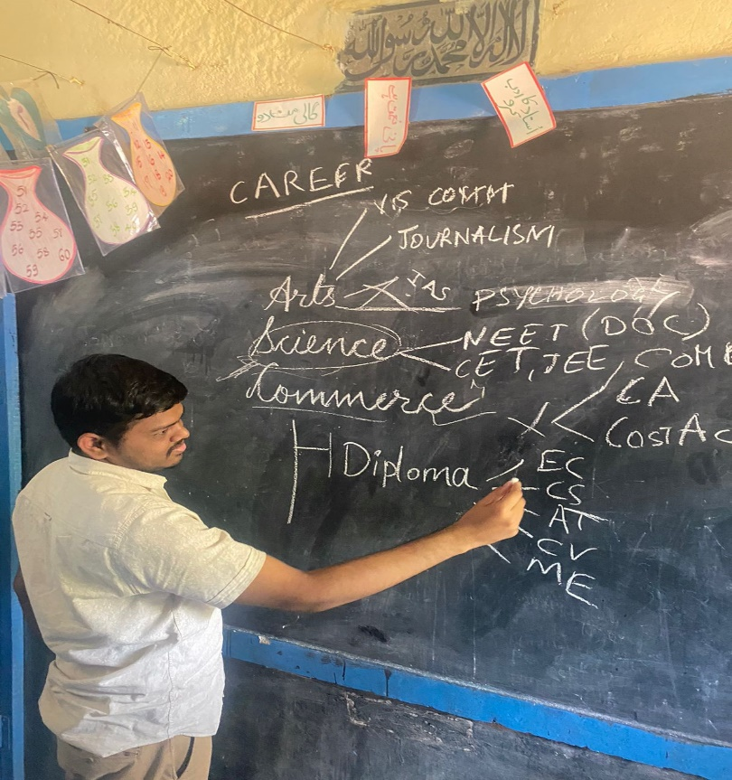

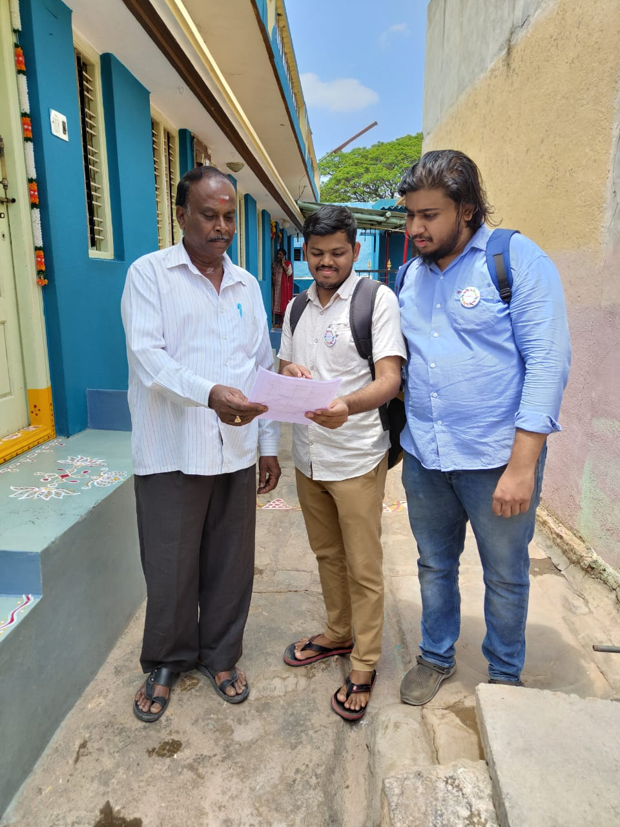

Fig: Creating awareness about govt school and benefit’s

**4. OUTCOME**

By this activity, we encourage all to bring about necessary regulatory and policy changes to facilitate the spread the scientific knowledge about career guidance and importance of education to the child which helps in motivating them to join schools and colleges. it also helps to bring change in the Indian economy by creating the next CEO and entrepreneur.

**5. CONCLUSION**

1. By doing this activity we were able to spread knowledge about education and career guidance to the kids who were studying in government school.

2. Also, we spread the knowledge about the education of a child to their parents which motivated them to send them to school and colleges.

**Certificate**

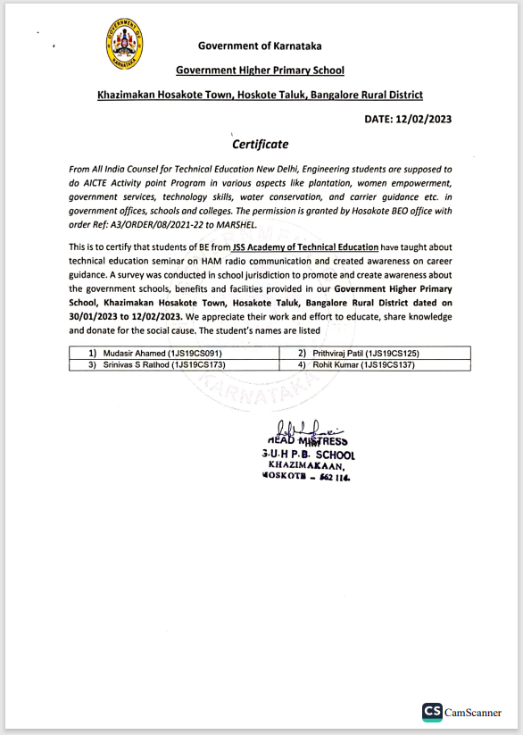

**ACTIVITY 3**

**ABOUT TOURISM PROMOTION**

**1. Executive of Summary or Abstract:**

In this activity, I, with the help of others, created Awareness on Tourism Promotion Innovative Approaches and conducted a survey on tourism places and automated local activities in Hosakote Taluk. We conducted the activity and awareness program near the Dodda Hosakote Lake, Bangalore Rural dated 20 th February- 26 th February, 2023.

**2. Introduction:**

Promoting tourism in rural areas requires an innovative approach that can help tap into the unexploited potential of these areas. Infusing technology in conducting and practicing rural tourism can be an effective way to promote rural tourism and attract more visitors. An innovative approach to sustainable rural tourism can help unveil local perceptions and attitudes regarding the impacts and benefits of tourism in rural areas. Tourism is one way of creating economic growth and simultaneously creating new jobs in rural regions, and it is essential to tap into the hitherto unexploited potential of these areas. Innovative organization approaches to sustainable tourism can help manage destinations in rural areas effectively and efficiently. Hoskote is a taluk in Bangalore Rural District. Headquartered at the Hoskote town, it consists of five hoblis - Anugondanahalli, Jadigenahalli, Kasaba, Nandagudi and Sulibele. Agriculture and horticulture are primary occupations of people here, although the industrialization in the recent times in Hoskote and places around has thrown up new opportunities for the people. Hoskote is the largest taluk in Karnataka having 333 villages. Restoration of lakes is important for several reasons. Lakes have intrinsic ecological and environmental values, and they moderate temperatures and affect the climate of the surrounding area. The restoration of a lake, especially shallow lakes that involve sediment removal, often leads to the eradication of toxic substances and improves water quality. Restoring dried up lakes in Bangalore is a challenging task, but there are several examples of successful restoration efforts that involve community effort, treatment of wastewater, and allocation of funds for restoration.

**3. Description of activity with photographs:**

As a part of social activity and also to achieve the activity points, me and my fellow students of JSSATE, undertook an initiative to survey the Dodda Hosakote Lake, near Hosakote Town. The Bruhat Bengaluru Mahanagara Palike (BBMP) has set aside funds to restore a number of lakes in Bangalore, and it hopes that local communities that live near the lakes will take an active role in maintaining them once the restoration is complete. The BBMP Lakes Department is responsible for protecting, conserving, reclaiming, regenerating, and restoring lakes in Bangalore, and it has schemes for desilting, deweeding, and constructing pathways/walkways. The BBMP-Lakes has formalized citizen engagement for lake maintenance, and if an active citizen group is willing to maintain the lake, BBMP will develop the lake by providing funds and technical support. Hence, we conducted a survey and found out that the farms located in the surrounding areas near the lake, and the residential buildings on the other side of the lake had caused the lake to dry up. The wastewater entering the lake premises from the industries nearby has led to the accumulation of dirt in the lake. We discussed with the nearby farm owners and proposed the idea of community effort to restore Hosakote Lake in a similar manner to the revival of Jakkur Lake.

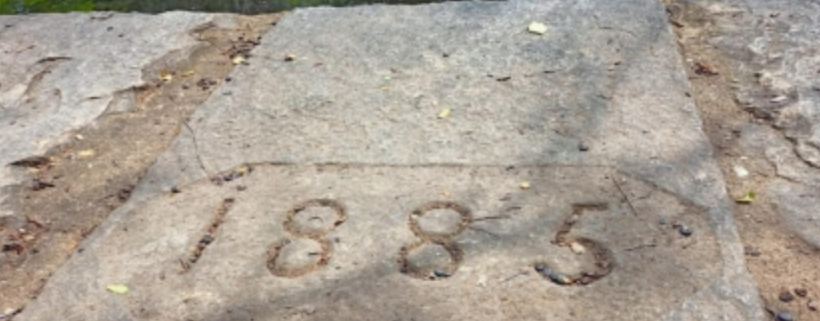

**Fig:** Surveying Dodda Hoskote Lake whose stone work was constructed in 1885

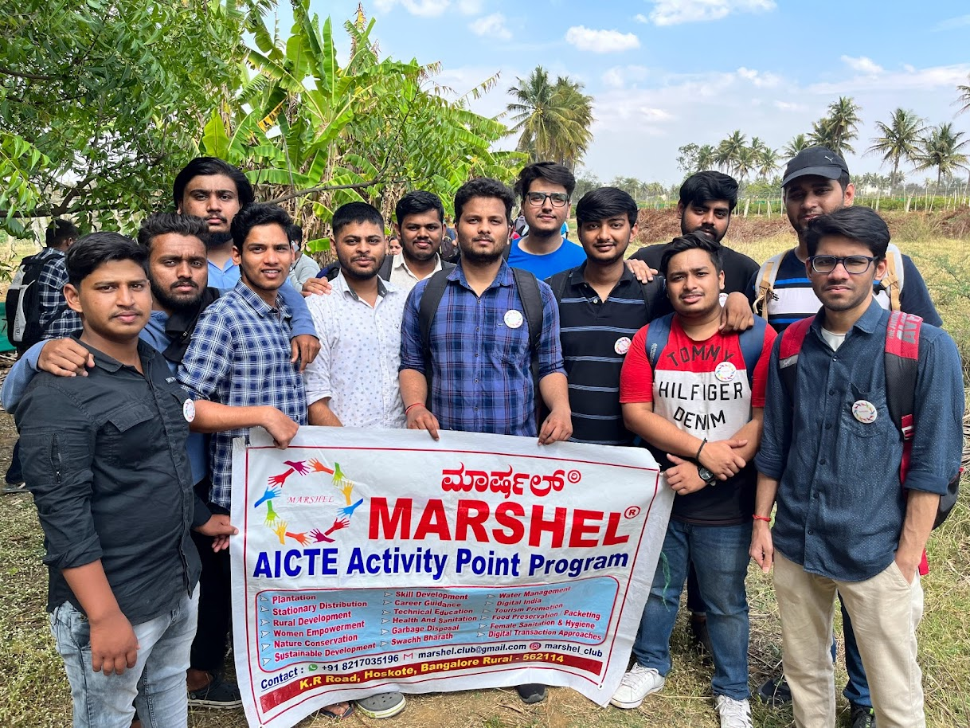

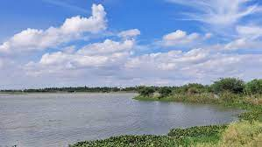

**Fig:** Lake side view

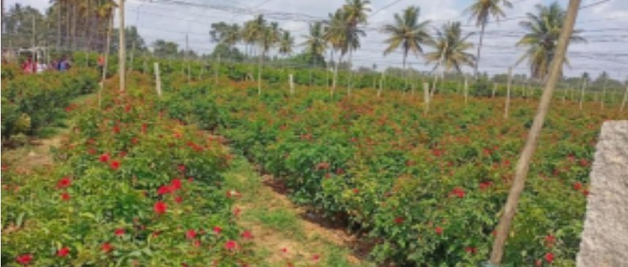

**Fig:** Farms surrounding the lake

**4. Conclusions:**

We were able to successfully create Awareness on Tourism Promotion Innovative Approaches and conducted a survey on tourism places and automated local activities in Hosakote Taluk, near the Dodda Hosakote Lake, Bangalore Rural dated 20th February- 26th February, 2023.

**5. Outcome or Takeaways from the activity:**

From this activity, we learnt the responsibility and importance of community efforts to maintain our surrounding areas. The BBMP-Lakes department will develop the lake by improving infrastructure, deploying home guards, etc., if an active citizen group is willing to maintain the lake. The restoration of Jakkur lake, with an integrated wetlands ecosystem, is an example of community effort in restoring a lake in Bangalore. Automation of local activities can help in reducing the inflow of sewage and treating wastewater before it enters the water body, which is essential for the restoration of lakes. Lakes in urban environments play a vital role in increasing biodiversity, aiding with flood control, providing a space for recreation, and helping community businesses thrive. Especially parks with lakes offer a range of recreational activities and can be an excellent spot for relaxation and enjoyment. Hence, a lake in an area can improve the neighborhood by providing opportunities for recreation, increasing biodiversity, aiding in flood control, and positively influencing the water quality of downstream watercourses

**Certificate:**

